--Show the date of check in and check out and number of nights for booking 5204

CREATE or ALTER VIEW vBooking5204

AS

SELECT booking_date as "check in", DATEADD (DAY, nights, booking_date) AS "check out", nights

FROM booking

WHERE booking_id=5204

select * from [dbo].[vBooking5204]

Scan count 0, logical reads 2, physical reads 1

CPU time = 0 ms, elapsed time = 43 ms.

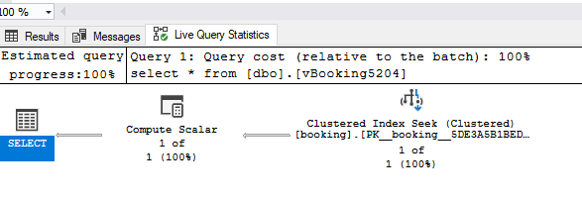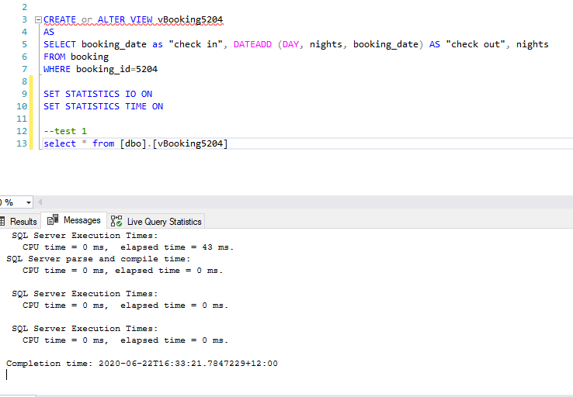CONCLUSION:

This is a good query. As we can see, in this query, a Clustered Index Seek is used to search the result. This is one of the most efficient ways for SQL Server to find single rows or small ranges, provided there is a filter that can be used efficiently. So ,for this query, I don’t carry more optimizing.